|  |
| --- |
|  |
|  |
| DOM API, jQuery | |
| Brief References for Self-Education | |

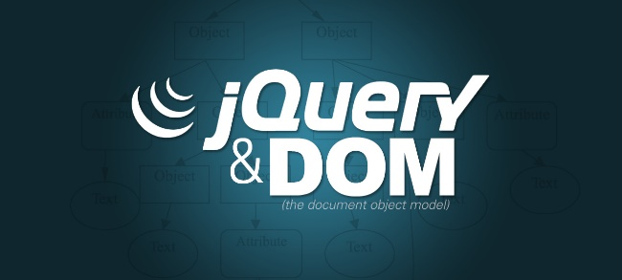

Contents

Plan 3

Notes 3

References 4

How to Read 4

Links 4

# Plan

1. What is DOM
2. DOM interfaces and implementation
   1. Events
   2. Methods
3. jQuery course
4. What is jQuery
   1. jQuery core
   2. Events
   3. Ajax
   4. Chaining
5. jQuery - Standards and best practices

# Notes

Learn the DOM. By doing that, you will have a better understanding and appreciation for what libraries like jQuery do for you. This also means you'll be better suited in the long run if you must change tools. The DOM will always be there, and is common ground for understanding the fundamental design choices for any given library that interacts with the DOM.

# References

## How to Read

⬛ Base Information

⬛ Common Ideas (not for deep reading)

⬛ Interesting to See

## Links

* ⬛ [Introduction to the DOM](https://developer.mozilla.org/en-US/docs/Web/API/Document_Object_Model/Introduction)
* ⬛ [DOM events](https://developer.mozilla.org/en-US/docs/Web/API/Document_Object_Model/Events)
* ⬛ [DOM examples](https://developer.mozilla.org/en-US/docs/Web/API/Document_Object_Model/Examples)
* ⬛ jQuery course
  + ⬛ [Lecture 1 - jQuery, write less, do more](https://wiki.itechart-group.com/screencasts/trainings/Front-End%20Development%20Training/DOM%20API/04-02-2013/DOM%20API%20Course%20-%20Lecture%201.mp4)
  + ⬛ [Lecture 2 - JS Tips And Tricks - DOM + jQuery Optimization (some information is not relevant at the moment)](https://wiki.itechart-group.com/screencasts/trainings/Front-End%20Development%20Training/DOM%20API/04-05-2013/DOM%20API%20Course%20-%20Lecture%202.mp4)
    - ⬛ Need to look attentively from 44:04 to 54:56
  + ⬛ [Lecture 3 - JS Tips And Tricks - DOM + jQuery Optimization (some information is not relevant at the moment)](https://wiki.itechart-group.com/screencasts/trainings/Front-End%20Development%20Training/DOM%20API/04-09-2013/DOM%20API%20Course%20-%20Lecture%203.mp4)
* ⬛ [Using jQuery core](https://learn.jquery.com/using-jquery-core/)

1. ⬛ [Document ready](https://learn.jquery.com/using-jquery-core/document-ready/)
2. ⬛ [Selecting elements](https://learn.jquery.com/using-jquery-core/selecting-elements/)
3. ⬛ [Traversing](https://learn.jquery.com/using-jquery-core/traversing/)
4. ⬛ [Manipulating elements](https://learn.jquery.com/using-jquery-core/manipulating-elements/)

* ⬛ [jQuery events](https://learn.jquery.com/events/)
  + ⬛ [jQuery Event Basics](https://learn.jquery.com/events/event-basics/)
  + ⬛ [Event Helpers](https://learn.jquery.com/events/event-helpers/)
  + ⬛ [Introducing Events](https://learn.jquery.com/events/introduction-to-events/)
  + ⬛ [Handling Events](https://learn.jquery.com/events/handling-events/)
  + ⬛ [Inside the Event Handling Function](https://learn.jquery.com/events/inside-event-handling-function/)
  + ⬛ [Understanding Event Delegation](https://learn.jquery.com/events/event-delegation/)
  + ⬛ [Triggering Event Handlers](https://learn.jquery.com/events/triggering-event-handlers/)
  + ⬛ [History of jQuery Events](https://learn.jquery.com/events/history-of-events/)
  + ⬛ [Introducing Custom Events](https://learn.jquery.com/events/introduction-to-custom-events/)
  + ⬛ [jQuery Event Extensions](https://learn.jquery.com/events/event-extensions/)
* ⬛ [jQuery Ajax](https://learn.jquery.com/ajax/)
  + ⬛ [Key Concepts](https://learn.jquery.com/ajax/key-concepts/)
  + ⬛ [jQuery’s Ajax-Related Methods](https://learn.jquery.com/ajax/jquery-ajax-methods/)
  + ⬛ [Ajax and Forms](https://learn.jquery.com/ajax/ajax-and-forms/)
  + ⬛ [Working with JSONP](https://learn.jquery.com/ajax/working-with-jsonp/)
  + ⬛ [Ajax Events](https://learn.jquery.com/ajax/ajax-events/)
* ⬛ [jQuery Deferreds](https://learn.jquery.com/code-organization/deferreds/)
* ⬛ [jQuery chaining](http://tobiasahlin.com/blog/quick-guide-chaining-in-jquery/)
* ⬛ [Coding Standards & Best Practices](http://lab.abhinayrathore.com/jquery-standards/)
* ⬛ [You might not need jQuery](http://youmightnotneedjquery.com/)